

Recruitment Pack

Director of international Student Recruitment

Job Reference: 1INTER2A

Closing date: 14th July at 5.00pm


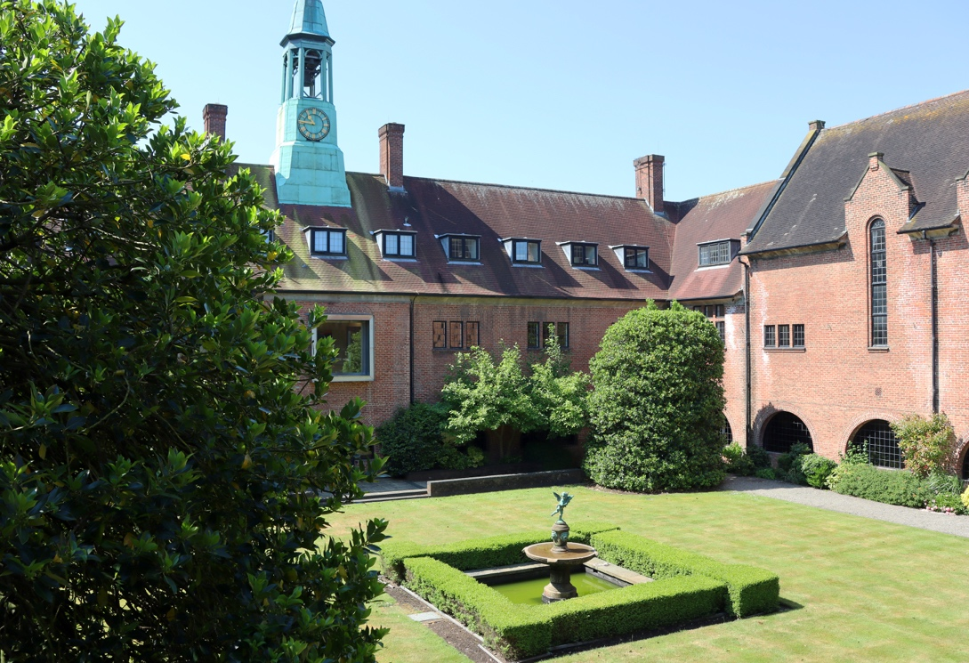




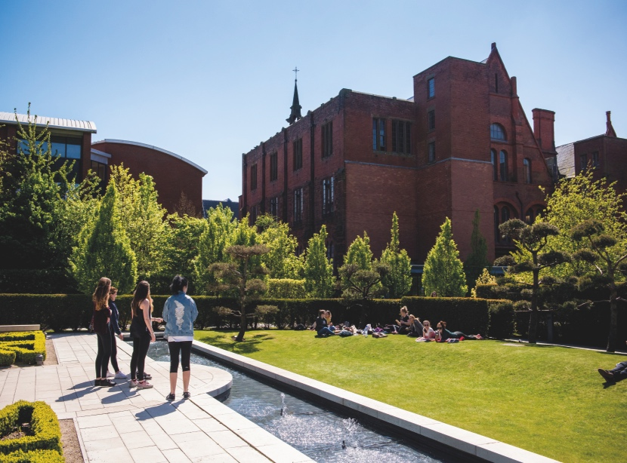




POST: Director of International Student Recruitment (Fixed Ter

STARTING DATE: TBC

SALARY RANGE: Grade 9 £58,226 to £67,469

TYPE OF CONTRACT: Fixed Term 12 months

WORK PATTERN: Full Time

REPORTS TO: Clare Beckett – PVC Marketing, Recruitment and Admissions

………………………………………………………………………………………………………………………………………………………….

The Post

Liverpool Hope University is a distinctive, values-led institution, rooted in a rich history and committed to delivering an outstanding student experience. As we enter a critical phase in our global development, we are seeking to appoint an exceptional, strategic and driven leader as Director of International Development.

This is a high-impact leadership opportunity to shape and deliver a transformed international recruitment and development agenda at a pivotal moment for the University.

Reporting to the Pro Vice-Chancellor Marketing, Recruitment & Admissions, the Director will provide decisive strategic leadership of international development, with a particular focus on international student recruitment, market diversification, and global brand positioning.

The role carries significant responsibility for driving institutional sustainability and growth, leading the transformation of international recruitment through a data-led, risk-aware and performance-driven approach. You will take ownership of the full international student lifecycle, from enquiry through to enrolment, ensuring a seamless and high-quality prospective student journey that maximises conversion and strengthens long-term engagement.

Primary responsibilities include leadership of the international recruitment team and development of capacity both in the UK and overseas, alongside oversight of market planning, student acquisition, channel strategy, conversion performance, international marketing, and alumni engagement. The successful candidate will lead the development and delivery of an ambitious and agile international recruitment strategy, driving improvement in performance, enhancing market diversification, and ensuring full compliance with UKVI requirements.

Working in close partnership with senior colleagues across the University, you will ensure a fully aligned, institution-wide approach to international growth. This includes collaboration with fellow Directors to deliver a seamless student experience, with the PVC MRA to expand partnerships, and with faculties and professional service teams to ensure activity is impactful and aligned with strategic priorities. The role also encompasses leadership of key global partnerships, including agents and pathway providers, and acting as an ambassador for Liverpool Hope University in the UK and internationally.

This role will require strong commercial acumen, strategic grip and pace, alongside the ability to lead through complexity, manage risk, and deliver measurable outcomes in a fast-moving environment. There will be opportunities for international travel as part of this global remit.

We are committed to building a diverse and inclusive workforce, and we particularly welcome applications from candidates from underrepresented groups, including those from global majority backgrounds and individuals with lived experience of international education.

This post is interim 1-year fixed term in the first instance, subject to the normal probationary period of 12 months.

………………………………………………………………………………………………………………………………………………………….

Job Description/Key duties of the post

International development is critical to Liverpool Hope University’s financial sustainability, global reputation, and regulatory compliance.

Reporting to the Pro Vice-Chancellor Marketing, Recruitment & Admissions, the Director of International Development provides decisive, expert leadership at a pivotal moment for the institution, shaping and delivering a high-impact international strategy that safeguards income, strengthens market position, and ensures compliance with UKVI requirements.

The role will lead the transformation and stabilisation of international student recruitment, driving a decisive shift to a data-led, risk-managed, and diversified global recruitment model. The post holder will take full accountability for the end-to-end international student lifecycle, ensuring a seamless, high-quality experience that maximises conversion, enrolment, and long-term engagement.

Key priorities include:
- Delivering a robust and agile international recruitment strategy aligned to institutional goals
- Stabilising and rebuilding recruitment performance in key markets
- Ensuring UKVI compliance and protection of the Student Sponsor Licence
- Driving market diversification and sustainable growth
- Strengthening global brand positioning and strategic partnerships

The Director will work closely with senior academic and professional service leaders to align recruitment, marketing, admissions, compliance, and student experience functions, ensuring a coherent institutional approach to internationalisation.

This is a high-impact leadership role with direct influence on institutional income (70–80%), requiring pace, authority, and strong commercial and regulatory acumen.

Key Tasks / Responsibilities
- Strategic Leadership
- Lead the development and delivery of a high-impact International Recruitment Strategy, aligned to institutional KPIs, financial targets, and global ambitions
- Drive rapid stabilisation, recovery, and long-term transformation of international recruitment performance
- Provide expert strategic advice to the University Executive, faculties, and senior leaders on global opportunities, risks, and growth priorities
- Recruitment & Performance Management
- Take full ownership of international recruitment targets, including student numbers, conversion rates, and income generation
- Oversee the complete international student lifecycle, from enquiry to enrolment, ensuring alignment across marketing, admissions, and conversion
- Implement a CRM-led, data-driven recruitment model, using insight to improve pipeline performance, conversion, and forecasting
- Develop and embed clear conversion strategies and CAS readiness planning
- Market Strategy & Risk Management
- Lead a risk-based market approach, pivoting away from over-reliance on high-risk markets and driving diversification
- Analyse internal and external data to prioritise markets and channels that deliver high-quality, compliant enrolments
- Monitor and actively manage visa refusal rates and compliance metrics
- Compliance & Governance
- Ensure all international recruitment activity complies fully with UKVI regulations, safeguarding the University’s Student Sponsor Licence
- Strengthen governance of CAS issuance, applicant credibility, and partner compliance
- Work closely with compliance teams to ensure robust quality assurance and risk mitigation processes
- Partnerships & Commercial Leadership
- Act as institutional lead for international commercial partnerships, including agents, pathway providers, and strategic partners
- Lead procurement, onboarding, and performance management of pathway providers and recruitment partners
- Develop and grow transnational education (TNE) and collaborative partnerships, ensuring clear business cases and delivery models
- Strengthen and professionalise the international agent network, implementing the Agent Quality Framework and enhancing oversight
- Team Leadership & Capability Building
- Lead, inspire, and develop a high-performing international recruitment team, setting clear objectives and fostering a culture of accountability and excellence
- Build organisational capability in data, conversion, customer experience, and compliance
- Promote a customer-centric and performance-driven culture
- Marketing & Brand Development
- Work in close partnership with Marketing and Communications to define and deliver a distinctive international brand and value proposition
- Shape targeted, insight-led campaigns in priority global markets
- Enhance Liverpool Hope’s global visibility and reputation
- Planning, Budget & Resources
- Hold responsibility for the international development budget, ensuring effective allocation and return on investment
- Lead annual planning processes, aligning activity with recruitment cycles and institutional priorities
- Negotiate and manage contracts to ensure value for money and strategic alignment
- Stakeholder Engagement & Representation
- Build strong relationships across faculties and professional services to ensure aligned delivery
- Represent the University externally in key sector networks (e.g., BUILA) and act as a senior ambassador internationally
- Engage with governments, embassies, and funding bodies to support recruitment and partnership development
- Continuous Improvement & Innovation
- Embed a culture of evaluation, insight, and continuous improvement
- Identify and implement innovative approaches to recruitment, conversion, and market engagement
- Lead the adoption of new technologies and systems to enhance effectiveness
- Compliance & Operational Oversight
- Ensure compliance with health and safety, data protection, and cyber security requirements
- Contribute to institutional policies including remote working, travel management, and staff wellbeing

………………………………………………………………………………………………………………………………………………………….

Person Specification

Educational Requirements | Essential  (E)/Desirable (D) | Method of  Assessment (A/I/P)
Educated to degree level (or equivalent) | E | A
Relevant professional or higher-level qualification | D | A
Membership of relevant professional body, sector groups / networks etc. | E | A
Experience | Essential  (E)/Desirable (D) | Method of  assessment
Leadership and management experience in a higher education setting | E | A/I
Strategy development experience relating to international recruitment and development | E | A/I
Experience of leading a student recruitment function in a fast-paced higher education environment, covering multiple international markets | E | A/I
Strong track record in managing resource (human and financial) to achieve and exceed defined targets | E | A/I
Experience of working with international recruitment agents, including management of performance, quality assurance and payments | E | A/I
Experience in leading change management initiatives | E | A/I
Demonstrable experience of and high-value partnership development and management, including with commercial and institutional partners, for recruitment purposes | E | A/I
Experience of managing pathway provider relationships | E | A/I
Experience of working with external stakeholders such as funding bodies, Government agencies and other enablers in the international recruitment arena to drive growth | E | A
Skills and Knowledge | Essential  (E)/Desirable (D) | Method of  assessment
Up to date knowledge of the UK higher education sector and the challenges it faces, particularly as related to international recruitment and development | E | A/I
Ability to work and communicate effectively with stakeholders at all levels, both internal and external | E | A/I
Extensive knowledge and understanding of management of the prospective student lifecycle | E | I
Commercial acumen and experience in negotiation, influencing and budget management | E | A/I
Strong analytical skills and experience of evidence-driven decision making | E | A/I
Highly developed written and verbal communication skills, including ability to handle complex and confidential information in accordance with regulations | E | A/I
Ability to work autonomously to tight deadlines, demonstrating initiative, prioritisation and organisation skills | E | A/I
Demonstrable commitment to continuous development within international operations | E | I
Any other requirements | Essential  (E)/Desirable (D) | Method of  assessment
Lived experience of international higher education | D | A
Ability to communicate in at least one additional language | D | A
Flexible and adaptable approach to work and able to work outside of normal hours as required | E | A
Ability to travel domestically and internationally on behalf of the institution | E | A
Commitment to providing a high-quality service underpinned by the institutional mission and values | E | A/I

………………………………………………………………………………………………………………………………………………………….

Contact for Queries

Clare Beckett
PVC Marketing, Recruitment and Admissions
becketc1@hope.ac.uk

Josua Peter
HR Manager
peterj@hope.ac.uk

………………………………………………………………………………………………………………………………………………………….

Conditions of service:

This post is based at Hope Park campus. However, you may be required to work in other areas of the University as and when required.

The post is permanent, subject to the normal probationary period of 12 months.

Salary scale for this post is grade 9 £58,226 to £67,469 per annum. New appointments will normally be made on the first incremental point of the advertised grade within the salary scale. In certain circumstances, it may be appropriate to offer a candidate a higher incremental point of the advertised grade. A higher salary will not be offered purely on the fact that it has been requested. Any starting salary above the first incremental point of the advertised grade must be justified and supported by evidence. Salary is payable monthly in arrears by bank giro credit on and around the 20th of each month.

The annual leave runs from 1st September to 31st August. Holiday entitlement is 32 days per year plus statutory Public Holidays and Liturgical days. This entitlement is pro-rated for part-time staff.

………………………………………………………………………………………………………………………………………………………….

Further Information

Liverpool Hope University has two main teaching campuses – Hope Park in the Liverpool suburb of Childwall and the city centre Creative Campus.

We have invested more than £60 million in buildings and equipment over the past eight years and we are proud of our campuses. Stunning listed buildings sit alongside modern architecture, and with beautiful gardens and facilities, which make Liverpool Hope University a unique place to work and study.

Mission and Values
Liverpool Hope University is an ecumenical Christian Foundation, which strives:
- to provide opportunities for the well-rounded personal development of Christians and students from other faiths and beliefs, educating the whole person in mind, body and spirit, irrespective of age, social or ethnic origins or physical capacity, including in particular those who might otherwise not have had an opportunity to enter higher education;
- to be a national provider of a wide range of high-quality programmes responsive to the needs of students, including the education, training and professional development of teachers for Church and state schools;
- to sustain an academic community, as a sign of hope, enriched by Christian values and worship, which supports teaching and learning, scholarship and research, encourages the understanding of Christian and other faiths and beliefs and promotes religious and social harmony;
- to contribute to the educational, religious, cultural, social and economic life of Liverpool, Merseyside, the North-West and beyond.

Liverpool Hope’s Values
Hope strives to meet the following values, which are integral to the fulfilment of its Mission:
- be open, accessible and inclusive,
- take faith seriously, being fully Anglican, fully Catholic, fully ecumenical, fully open to those of all faiths and beliefs,
- be intellectually stretching, stimulating, challenging,
- be hospitable, welcoming, cheerful, professional, full of Hope; creating supportive communities in aesthetically pleasing environments,
- be well-rounded, holistic, integrated, a team, a community of communities, collaborating in wider partnerships.

Equality and Diversity
Consistent with its Mission, Liverpool Hope strives to be a University where the individual and individuality matter. We hold students, staff and visitors in high regard and we seek to foster a working and learning environment that recognises and respects difference. All staff are expected to comply with the University’s Equality and Diversity policies in the performance of their duties.

Health and Safety
Liverpool Hope University is committed to ensuring the health, safety and welfare of all staff at work and of students, visitors and others by continuous improvement in standards of health and safety. All staff are expected to comply with the University’s Health and Safety policies in the performance of their duties

Sustainability
Liverpool Hope University is committed to enhancing the quality of its environment for its staff and students working and living at the University and the wider community; and aims to manage its operations in ways that are environmentally sustainable, economically feasible and socially responsible. All staff are expected to work in accordance with and promote the University’s sustainability practices.

………………………………………………………………………………………………………………………………………………………….

Benefits of working at Liverpool Hope University

Liverpool Hope offers its employees a full range of benefits:

Pay and Pensions
- Competitive rates of pay defined using the HERA job evaluation scheme
- Pension schemes with generous employer contributions

Home and Family
- Generous Annual Leave Arrangement
- Opportunity for flexible working arrangements

Training and Development
- Induction training for all new staff
- Staff development opportunities

Health and Well-Being
- Hope Park Sports fitness suite and classes with discounted membership
- A range of food outlets with healthy eating options
- Staff counselling service
- Staff cycle scheme
- Support with lifestyle changes
- A range of social activities and groups
- On-site chapel, multi-faith prayer room and Chaplaincy
- Eye testing scheme

We also provide a variety of staff discounts ranging from reduced price Theatre tickets to discounts on beauty treatments.

Library services
Liverpool Hope’s Library Service provides access to a wide-ranging collection of physical and online resources to support learning and research. The service also provides different types of study space across both campuses to support the wide range of learning styles and needs, from individual study rooms to group spaces, and from silent study to more relaxed social learning

Car Parking
All users of University car parks are required to pay for their use. The University has a scalable charging system for annual permits and pay and display facilities for occasional users.

We recruit staff nationally and internationally as we seek out the best to help build Hope for the future. If you join us, you will be doing so at an exciting and challenging time as we work to build a liberal arts inspired university of distinction in the UK.

………………………………………………………………………………………………………………………………………………………….

How to apply

You can download the application form by the link below:

How to apply

Useful Links

www.hope.ac.uk/lifeathope/welcome
https://www.hope.ac.uk/gateway/staff/peopleservices/
www.hope.ac.uk/jobs

………………………………………………………………………………………………………………………………………………………….











